DocSpot – Seamless Appointment Booking for Health
PROJECT REPORT

1. INTRODUCTION
1.1 Project Overview
DocSpot is a full-stack web-based doctor appointment booking system developed using the MERN stack (MongoDB, Express.js, React.js, and Node.js).
The application provides a centralized platform for patients to easily book medical appointments online. It enables doctors to manage their schedules, confirm bookings, and update appointment statuses efficiently. The admin module ensures proper governance by approving doctor registrations and monitoring system activities.
The system supports secure authentication, real-time availability tracking, and role-based access control.
1.2 Purpose

The purpose of the DocSpot project is to modernize the traditional doctor appointment system through digital transformation. It aims to eliminate long waiting times by enabling patients to book appointments online from anywhere. The system provides real-time doctor availability, allowing users to select convenient time slots instantly. It facilitates efficient online appointment management for patients, doctors, and administrators. The platform ensures secure access with role-based authentication and centralized monitoring.

2. IDEATION PHASE
2.1 Problem Statement
Traditional doctor appointment booking systems are mostly manual, requiring phone calls or in-person visits. These methods are time-consuming and often lead to long waiting periods for patients. Manual record management can result in scheduling conflicts and human errors. Patients may struggle to find available doctors or suitable time slots quickly. Doctors also face difficulties in managing appointments efficiently without a proper system.

2.2 Empathy Map Canvas
Who? Patients, Doctors, Admin
Think & Feel: Patients feel frustrated with waiting times. Doctors feel overloaded managing manual appointments.
Hear: "Please wait on hold." "Doctor is unavailable."
See: Crowded hospitals Manual booking registers
Pain: Time-consuming booking , Miscommunication , Appointment conflicts
Gain: Quick booking , Real-time updates , Better appointment tracking

2.3 Brainstorming
- Online doctor listing
- Real-time appointment slots
- Role-based authentication (Admin, Doctor, User)
- File upload for medical records
- Notification system
- Dashboard for each role
- Secure login using JWT

3. REQUIREMENT ANALYSIS

3.1 Customer Journey Map
Stage | Action | Feeling | Opportunity
Awareness | User searches for doctor | Worried | Provide online platform
Consideration | Views doctor list | Confused | Filter by specialization
Decision | Books appointment | Relieved | Instant confirmation
Action | Visits doctor | Confident | Medical consultation

3.2 Solution Requirements

Functional Requirements:
- User Registration & Login
- Doctor Registration & Admin Approval
- Appointment Booking
- Appointment Cancellation
- Appointment Status Tracking
- Notification System
- Admin Dashboard

Non-Functional Requirements:
- Secure authentication (JWT)
- Scalable database (MongoDB)
- Fast API response
- User-friendly UI

3.3 Data Flow Diagram

Level 1 DFD:
User → React Frontend → Express Server → MongoDB → Response → UI

Level 2 DFD:
User Input → Validation → API Call → Controller → Database → Status Update → Notification → UI Display

3.4 Technology Stack

Frontend : React.js , Bootstrap , Ant Design , Axios

Backend : Node.js , Express.js , JWT Authentication , Middleware

Database : MongoDB , Mongoose

Tools : Git & GitHub , Postman , VS Code

4. PROJECT DESIGN

4.1 Problem Solution Fit
Manual booking systems lack efficiency and transparency.
Doc Spot provides:
- Real-time scheduling
- Centralized management
- Role-based dashboards
- Automated appointment flow

4.2 Proposed Solution
A MERN-based web application where:
- Users register and book appointments
- Doctors manage appointment requests
- Admin approves doctors and oversees platform
The system ensures secure authentication, real-time data exchange, and scalable architecture.

4.3 Solution Architecture
Client–Server Architecture:
React Frontend
⬇
Axios API Calls
⬇
Express Backend
⬇
MongoDB Database

5. PROJECT PLANNING & SCHEDULING
Task | Timeline | Responsibility
Requirement Analysis | Day 1 | All members
Database Design | Day 2 | Member 1&2
Backend Development | Day 3 | Member 3&4
Frontend Development | Day 4 | Member 4&5
Integration | Day 5 | All Team
Testing & Deployment | Day 6 | All Team

6. FUNCTIONAL & PERFORMANCE TESTING

6.1 Functional Testing
- User Registration Test
- Login Authentication Test
- Doctor Approval Test
- Appointment Booking Test
- Status Update Test
- Cancellation Test
All APIs were tested using Postman.

6.2 Performance Testing
- Fast API response (< 2 seconds)
- Secure password hashing using bcrypt
- Token-based authentication using JWT
- Efficient CRUD operations

7. RESULTS
7.1 Output Screenshots
• Home Page

• User create Account page
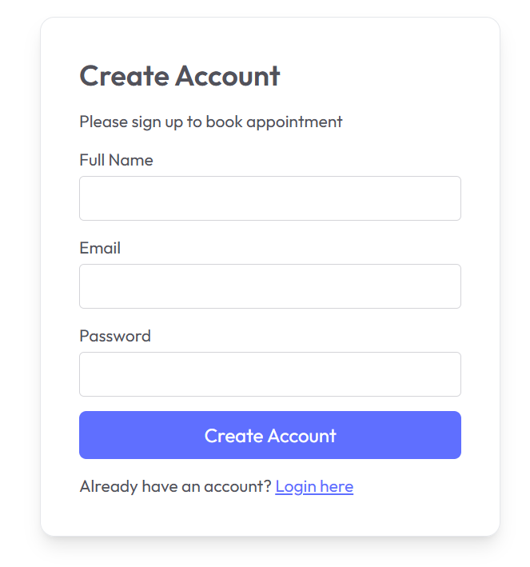
• user login page
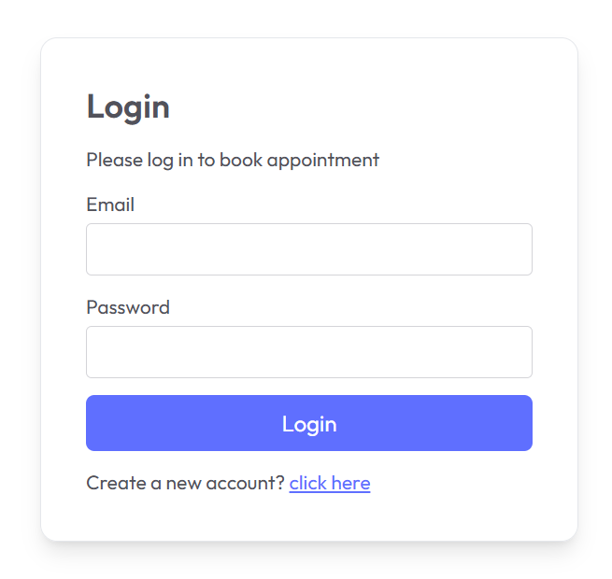
• Doctor login page
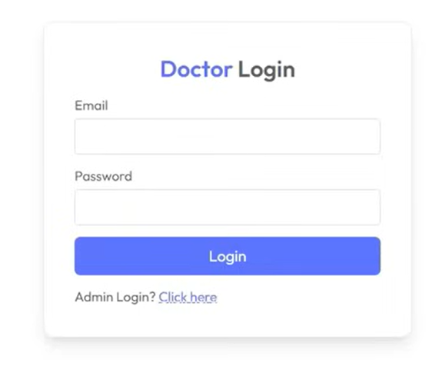
• Doctor Dashboard page
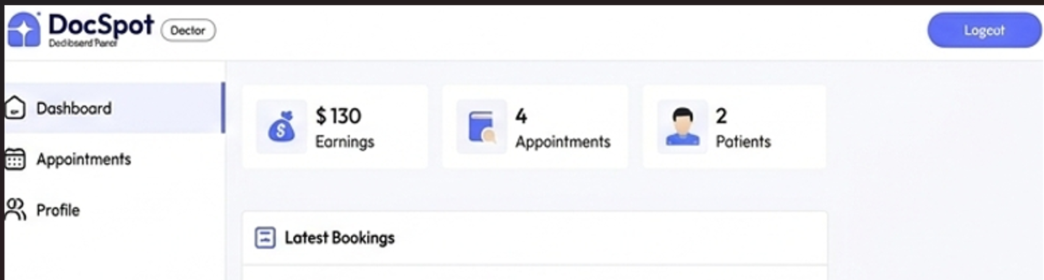
• Admin login page
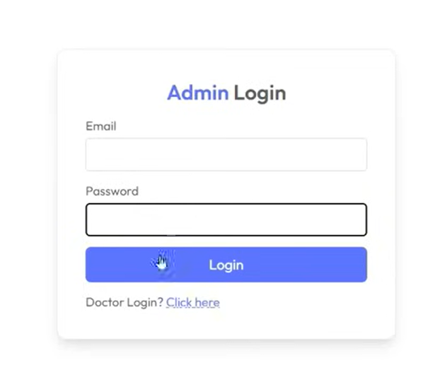
• Admin Dashboard page
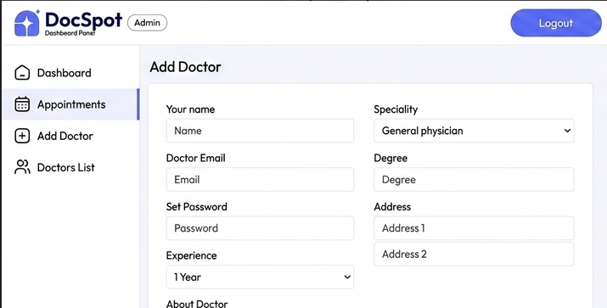

8. ADVANTAGES & DISADVANTAGES

Advantages:
- Real-time booking
- Role-based access
- Secure authentication
- Easy to use
- Scalable architecture

Disadvantages:
- Requires internet connection
- Not integrated with hospital EMR systems
- Basic notification system

9. CONCLUSION

Doc Spot successfully demonstrates the implementation of a full-stack MERN application for healthcare appointment booking. It simplifies the traditional appointment system by providing real-time availability, secure authentication, and centralized management.

10. FUTURE SCOPE

• Online payment integration
• Video consultation feature
• SMS/Email notifications
• Mobile application version

11. APPENDIX

GitHub & Project Demo Link:
GitHub Repository:
https://github.com/YVDSAI/Doc-Spot-Seamless-Appointment-Booking-for-Health

Project video Link:
https://drive.google.com/file/d/1-B803CypD1f_5hnSFNYKbOrXEey-Tkhw/view?usp=drivesdk

